**MEMORANDUM OF AGREEMENT**

This **MEMORANDUM OF AGREEMENT** (“**MOA**”) is made, entered into and effective as of **____________________**, in the City of **Pasig** by and among:

**POSITIVE EXPOSURE PRODUCTIONS, INC.,** a corporation duly organized and existing under Philippine Laws and herein represented by the duly authorized representative **MARINEL BARQUIN LEE,** CEO, with address at Unit 909 Tycoon Corporate Centre, Pearl Drive, Barangay San Antonio, Pasig City, hereinafter referred to as **“PEP or Project Integrator”**.

and

**_______________________________**, a corporation duly organized and existing under Philippine Laws and herein represented by **____________________**, ____________________________ with address at ______________________________hereinafter referred to as “**PARTNER**”.

(Each a “**Party**” and collectively, the “**Parties**”)

**RECITALS:**

**WHEREAS**, pursuant to President Ferdinand “Bongbong” Marcos, Jr.’s vision for the country’s tourism to take a principal role in economic recovery and resurgence, DOT Secretary Christina Garcia Frasco presented three focus points that consider the perspective of a traveler: through Connectivity, Convenience and Equality).

**WHEREAS**, the DOT has set its sights on advancing programs that will boost the country’s tourism industry and contribute to “improving the overall Philippine experience.”

**WHEREAS**, the DOT-NCR has successfully launched and now in full operations- the **Metro Manila Hop-On Hop-Off (HOHO): Travel by Hub Project**, a special tourism recovery program that  aims to showcase Metro Manila through a world-class transport and tour booking system and a proof of concept of Digitalization, Private-Public Partnership and Inclusivity.

**WHEREAS**, the program addresses the need for a seamless, contactless travel system within select strategic hubs or districts of Metro Manila while providing tourists options for quick, *Do-It-Yourself* tours. The Program allows group travelers and FITs (Fully Independent Individual Travelers) the freedom to choose where and how to tour Metro Manila, starting with the Cities of Manila, Makati, Pasay and Paranaque.

**WHEREAS**, following the launch of Entertainment Hub: Pasay and Paranaque on Feb 8, 2024, the DOT Secretary Garcia Frasco, has officially carried out the inception of **Phase 2** of Philippine Tourism Digitalization through another ground-breaking project **LOVE Metro Manila** (Localized Online Visitor Ecosystem) and its ancillary program the **HOHO TRANSIT TOUR, LUXURY TOURS and DEPLOYMENT OF MESH WIFI** (the “**Programs**”)**.**

**WHEREAS**, the effective and efficient implementation of the Project requires the collaboration between the private and public sectors, [COMPANY NAME] has been identified as a key strategic partner whose products, services, and expertise will not only augment the travel experience for tourists but also strengthen the Program’s capacity to deliver accessible, high-quality, and inclusive tourism services.

**NOW, THEREFORE**, for and in consideration of the foregoing premises, the PARTIES, through their respective authorized representatives, do hereby agree to undertake the following:

1. **TERM.** This Agreement shall commence as of the Effective Date above stated and shall be in full force and effect for a period of 2 years, unless terminated earlier upon agreement by the Parties.
2. **RESPONSIBILITIES OF THE PARTIES:**
3. **PEP** shall:
   1. Act as the main Project Integrator of Phils. HOHO and LOVEMM Project Operations including Phils. HOHO Logistics and Bus operations under Memorandum of Agreement dated July 2023, LOVEMM Systems and Customer Center management and maintenance, , customer service, coordination with NNIC with regard to LOVEMM Project operations and marketing implementations and relevant government agencies , and technical support to ensure seamless execution of the transit tour.
   2. 3.2 As the Lead Consultant for the Deployment of LOVEMM Project, PEP is responsible for ensuring the efficient execution of tasks and activities, rendering the required services, and delivering Project Requirements. PEP oversees project execution, provides strategic direction, manages remuneration and direct costs, and ensures compliance with financial obligations. PEP collaborates closely with the Project Owner the Department of Tourism, , refrains from making decisions that engage them beyond contractual obligations without prior written consent, and maintains open communication with the Project Owner and other Partners regarding project delivery. PEP ensures timely notification of delays, accurate information sharing, and error correction. Acting in good faith, PEP must obtain written permission before using another Project Owner’s and Partners’ pre-existing knowledge, materials, or intellectual property. PEP is responsible for maintaining confidentiality, adhering to the Main Contract's terms, and sharing necessary information with entities outside the project solely for project purposes. Additionally, PEP coordinates scheduling and task synchronization with other Project Owners and other Partners to ensure seamless project execution.
4. **PARTNER** shall:

2.1 Share relevant API data for seamless integration of accommodation booking, amenities, and services into HOHO platforms.

2.2 Curate and provide exclusive offers and packages for HOHO app users to encourage increased bookings and guest engagement.

2.3 Update PEP on availability of products and services, promotions, and special rates applicable to HOHO users.

2.4 Engage in cross-promotional activities with HOHO and DOT to enhance visibility and attract new customer segments through joint marketing efforts.

2.5 Promote the HOHO Program through posts and updates and by disseminating relevant information on Partner’s social media accounts and property areas, including but not limited to Indoor LEDs, Outdoor Large OOH Sites, and In-room LED Playback if available. Media promotions, including campaigns on social media platforms, will follow aMedia Planprepared by PEP.

2.6 Provide designated areas for HOHO promotional activities upon request by PEP and subject to written approval.

2.7 Provide rough estimated foot traffic data for analysis and future promotional activities upon request by PEP and subject to written approval.

2.8 Supply property assets, such as videos, photos, information, and write-ups selected by the Partner, for use in In-Bus videos, mobile app content, marketing collaterals, publicity, and social media posting.

2.9 Sell and deliver only ethical, high-quality products and services, in compliance with all applicable laws, industry standards, and local government regulations. The following matters shall be ensured:

* Tour Services: All tours shall comply with all laws, safety standards, and guidelines, with highly qualified and trained personnel.
* Retail items: Only products that are of high quality, free from defects, and meet the agreed-upon specifications, standards, and safety regulations shall be offered.
* Services: All services provided adhere to professional standards of care and quality. All service offerings must meet the specifications as agreed upon by both Parties, and the Partner must provide details of any procedures, safety protocols, and restrictions related to the services.

3.0 Provide clear, comprehensive details on the use, procedures, restrictions, and safety protocols for their products, services, and tours. The Partner guarantees the timely delivery of all products and services in full and in high-quality condition.

3.1 Ensure timely fulfillment and adherence to the agreed-upon standards for all products, services, and tours

3.2 Indemnify PEP to the fullest extent applicable against any and all claims, damages, losses, liabilities, disputes, refunds, chargebacks or expenses, including legal fees, arising from defective products, improper services, negligence, or failure to meet the standards or obligations under this Agreement.

3. **Both parties** shall:

3.1 Collaborate to ensure a smooth user experience across all platforms (mobile, web, and kiosk).

3.2 Conduct regular reviews to assess integration success, adjust pricing or offerings as needed, and address any operational or technical issues.

3.3 Uphold data security and privacy standards, ensuring user data is protected in compliance with relevant regulations.

1. **DELIVERY OF PRODUCTS AND SERVICES**
2. **Digital Products**

1.1. Digital products, including but not limited to vouchers and booking reservations, will be made available on the HOHO platform, where customers can download and print them at their convenience upon successful purchase or booking.

1.2. An email copy of the digital product, containing all relevant details such as redemption instructions, validity periods, and terms of use, will also be sent to the customer’s registered email address.

1.3. Customers are responsible for ensuring their contact information is accurate to facilitate the successful delivery of email copies.

### Physical Products

2.1. For physical products purchased, Positive Exposure Productions, Inc. (PEP) shall collaborate with a third-party logistics company to deliver items to the customer’s specified address at the time of purchase.

2.2. PEP will collect delivery fees at checkout and remit the payment to the third-party logistics company accordingly. The Partner shall ensure proper packaging of the items and timely dispatch to the logistics partner while also updating the customer regarding the delivery status.

2.3. The Partner and the logistics partner shall ensure a **100% delivery fulfillment rate**, with all items delivered to the customer in good condition and within the agreed timeframe. In case of delays, lost items, or damages, the Partner will work with the logistics partner to resolve the issue promptly and ensure customer satisfaction.

1. **Liabilities**

3.1. PEP shall not be liable for delays, loss, or damage caused during the delivery of physical products once handed over to the logistics partner.

3.2. For defective or incorrect physical products delivered, the Partner will facilitate the return or replacement process as per the applicable Return and Exchange Policy.

3.3. The Partner is responsible for ensuring digital products are accessible on the platform and email copies are sent promptly but shall not be liable for issues arising from incorrect customer details or technical issues outside the Partner’s control.

3.4 The Partner shall fully indemnify PEP to the fullest extent applicable against any and all claims, damages, losses, **disputes, refunds, chargebacks** or expenses including legal fees arising from accidents, injuries, or mishaps during tours, including but not limited to those caused by the Partner’s negligence, failure to adhere and comply with safety standards, and/or defective products or services.

1. **Customer Responsibilities**  
   4.1. Customers must ensure that their account information, including email and delivery address, is accurate and up to date.

4.2. Customers are responsible for adhering to the redemption policies and deadlines stated in their digital vouchers or booking reservations.

1. **COLLECTION & SETTLEMENT OF FEES:** Payments will be processed through a designated payment gateway, which will incur a five percent (5%) convenience fee, delivery charges (if applicable), and payment gateway fees, all of which will be added on top of the listed price charged to the user. After deducting the aforementioned charges, the remaining balance will be credited to the Partner's designated bank account. The Partner shall receive the remaining amount within seven (7) business days from the date of the transaction. The detailed breakdown is attached as Annex “A” and made an integral part of this Agreement.

In the event of any discrepancies, disputes, or issues concerning payments, including additional charges, the following shall apply:

1. The Partner shall notify PEP in writing within seven (7) calendar days from the date of occurrence of the disputed transaction, providing relevant supporting documents and a written explanation.
2. PEP shall review and verify the claim within ten (10) business days of receipt of the notification.
3. If the dispute is valid, PEP shall make the necessary adjustments and/or settlements within seven (7) business days from resolution;
4. Any unresolved disputes will be subject to the Governing Law and Venue of Actions provisions of this Agreement.
5. **MANNER OF PERFORMANCE.** The Partiesshall fulfill their commitments and undertaking in this MOA by using knowledge according to the best accepted professional standards, exercise all reasonable skill, care, and diligence in the discharge of duties agreed to be performed, and work in the best interest of all the Parties.
6. **AUDIT AND MONITORING.** PEP reserves the right to audit the Partner’s integration with the HOHO platform and marketing activities to ensure compliance with the terms of this Agreement. Such audits shall be conducted during regular business hours with prior written notice.

The Partner agrees to cooperate and provide any and all necessary documentation, reports, or access to systems to facilitate such audits.

1. **TERMINATION.**

Either Party may terminate this Agreement under any of the following circumstances:

1. A Party fails to perform any material obligation under this Agreement and does not remedy such failure within thirty (30) calendar days after receiving written notice from the other Party;
2. By mutual written consent of both Parties; or
3. If a Force Majeure event prevents performance of the obligations under this Agreement for more than sixty (60) consecutive days.

Upon termination of this Agreement, both Parties agree to:

1. Immediately cease using any intellectual property, promotional materials, or resources of the other Party, except as necessary to fulfill the remaining and outstanding obligations to customers;
2. Facilitate the winding-down of operations, including the removal of Partner services from the HOHO platform, settlement of accounts, and delivery of any pending products or services; and
3. Resolve all unsettled financial obligations within thirty (30) calendar days of the date of termination.
4. **FORCE MAJEURE.**

Neither Party shall be liable for any delay or failure to perform its obligations under this Agreement due to events beyond its reasonable control, including but not limited to natural disasters, acts of government, pandemic restrictions, or disruptions in communication infrastructure.

The affected Party shall notify the other Party within five (5) business days of the occurrence of such an event. Both Parties shall use reasonable efforts to minimize the impact of the Force Majeure event on the performance of this Agreement.

If a Force Majeure event prevents performance for more than sixty (60) consecutive days, the other Party is entitled to terminate the Agreement.

1. **NON-WAIVER.** Failure of any Party to insist upon strict performance of any of the terms, conditions, and covenants in this MOA shall not be deemed a relinquishment or waiver of any rights or remedies that such Party may have, nor shall it be construed as a waiver of any breach or default of the terms, conditions, and covenants, which shall continue to be in full force and effect. No waiver by a Party of any of its rights under this MOA shall be deemed to have been made unless expressed in writing and signed by all the Parties.
2. **AUTHORIZED REPRESENTATIVES.** Any action required or permitted to be taken, and any document required or permitted to be executed, under this MOA by the Parties, may be taken or executed by the Authorized Representatives: **Marinel Barquin Lee** for PEP, and **_____________** for___________ respectively.
3. **NOTICES**. Any notice, request, or consent required or permitted to be given or made pursuant to this MOA shall be in writing.  Any such notice, request, or consent shall be deemed to have been given or made when received by the concerned party, either in person or through an authorized representative ofthe Party to whom the communication is addressed, or when sent by registered mail, telex, telegram or facsimile to such Party at the address specified below:

**Positive Exposure Productions, Inc.**

Attention: Marinel Barquin Lee

Address: 909 Tycoon Corporate Centre,

Pearl Drive, Brgy. San Antonio, Pasig City

Email Address: **marinel@pepmedia.ph**

**______________________**

Attention: ________________________

Address: _________________________

Email Address: ___________________________________

1. **CONFIDENTIALITY.** Except with the prior written consent of all the other Parties, a Party and/or any of its employees and/or person shall not at any time communicate to any person or entity any confidential information acquired in the course of the partnership, nor shall a Party and/or any of its employees and/or personnel make public the recommendations formulated specifically for either or both of the other Parties in the pursuance of this MOA. For purposes of this clause, **“Confidential Information”** means any information or knowledge acquired by a Party and/or any of its employees and/or personnel arising out of, or in connection with this MOA, that is not otherwise available to the public. This clause shall be subject to applicable laws relating to freedom of information.
2. **DATA PROTECTION.** The Parties agree to comply with the provisions of Republic Act No. 10173 or the “Data Privacy Act of 2012,” its Implementing Rules and Regulations, and all other rules and regulations relevant to data privacy and the protection of personal information.

In the event of unauthorized access or data breaches involving personal information, caused by fault or negligence of the Partner:

1. The Partner shall immediately notify PEP of such incidents within 24 hours of discovery of such incident.

1. The Partner shall bear any and all costs associated with mitigating the breach, including but not limited to, legal fees, fines, penalties, and compensation to affected parties.

1. The Partner shall provide full cooperation to PEP in investigating the incident and implementing corrective measures.

1. The Partner shall indemnify PEP to the fullest extent applicable against all claims, damages, losses, liabilities, and expenses arising from such breaches.
2. **INTELLECTUAL PROPERTY**. The Parties understand and agree that each Party will retain all rights in its own proprietary materials, rights, technology, and intellectual property that originate from or are solely developed by such Party.
3. **SURVIVAL OF PROVISIONS.** The provisions of this Agreement that by their nature extend beyond its termination, including but not limited to confidentiality, indemnity, data protection, intellectual property rights, and governing laws, shall survive and remain in effect after the termination of this Agreement.
4. **GOOD FAITH.** The Parties undertake to act in good faith with respect to each other’s rights under this MOA and to adopt all reasonable measures to ensure the realization of the objectives of this MOA.
5. **INDEMNITY**. Each Party shall release, waive, and forever hold the other Party free and harmless, and shall indemnify the latter, its stockholders, directors, officers and employees against, any and all claims, demands, costs, damages or liability whatsoever or any lawsuit, including reasonable attorney’s fees, arising, directly or indirectly, from the operations, breach, omission or negligence, or based upon violation or infringement of any ownership, intellectual property or other proprietary right of any third party, by the Party in the performance of its rights and obligations under this Agreement or of its employees, representatives and/or agents.
6. **GOVERNING LAW AND VENUE OF ACTIONS**. This Agreement shall be governed by and construed in all respects in accordance with the laws of the Philippines and the venue of all court actions arising from any conflict or dispute in the interpretation or enforcement of this Agreement shall be the appropriate court of Pasay City, to the exclusion of any other court in other cities/territorial jurisdictions.
7. **COMPLETENESS**. This MOA is complete and contains all the terms and conditions agreed upon by all Parties hereto; and no other agreement regarding the subject matter of this MOA shall be deemed to exist or to bind any of the parties hereto, except upon written agreement signed by all Parties, and expressly referencing this MOA.
8. **SEPARABILITY.** If any of the material provisions of this MOA should be invalid, illegal or in conflict with any existing and applicable laws, the remaining provisions shall be implemented as far as practicable, valid and enforceable.

**IN WITNESS WHEREOF,** the parties have caused the execution of this *Memorandum of Agreement* through their duly authorized representatives on ____________ at ______________________.

| **POSITIVE EXPOSURE PRODUCTIONS, INC.**  By:  __________________________  **MARINEL BARQUIN LEE** | **COMPANY**  By:  __________________________  **[NAME]** |
| --- | --- |
|  |  |

WITNESS:

_________________________ _________________________

**ACKNOWLEDGMENT**

**BEFORE ME**, A Notary Public for and in ___________________, this _________________, personally appeared the following with their competent evidence of identity:

| **Name** | **ID Presented** | **Valid Until** |
| --- | --- | --- |
|  |  |  |
|  |  |  |
|  |  |  |

known to me to be the same persons who executed the foregoing instrument and they acknowledged to me that the same is their own voluntary act and deed.

**WITNESS MY HAND AND SEAL** on the place and date first above-written.

Doc. No. _____;

Page No. _____;

Book No. _____;

Series of 2024.

**ANNEX “A”**

**COLLECTION & SETTLEMENT OF FEES**

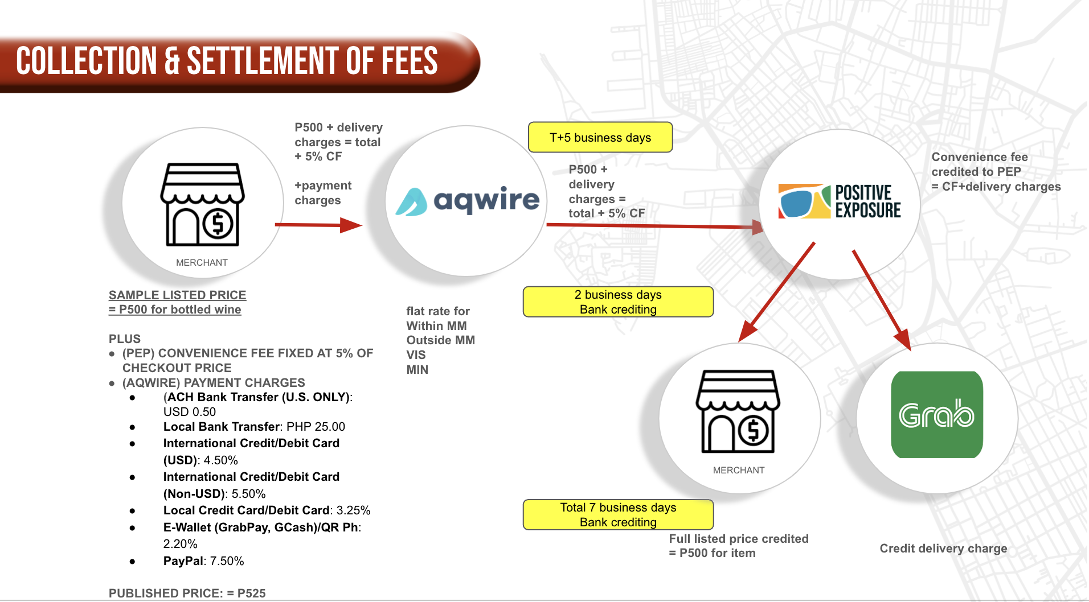

The process for collecting and settling fees under this Agreement is designed to ensure transparency, accountability, and efficiency in all transactions. The workflow is as follows:

1. **MERCHANT PRICING AND ADDITIONAL CHARGES.**

Merchants determine a listed price for their products or services (e.g., ₱500 for a bottle of wine). Additional fees are applied to this base price, including:

* A 5% Convenience Fee (CF) charged by Positive Exposure Productions (PEP).
* Payment processing charges applied by Aqwire.

1. **CHECKOUT PROCESS.**

At checkout, the total amount to be paid by the customer includes:

* The merchant's listed price.
* Delivery charges, if applicable.
* The 5% Convenience Fee.
* Aqwire’s payment processing charges.

1. **PAYMENT DISTRIBUTION VIA AQWIRE:**Aqwire deducts its payment processing charges and transfers the remaining amounts as follows:

* The full listed price (₱500) is credited to PEP.
* The delivery charges, if any, are credited to the designated delivery partner (e.g., Grab).
* PEP retains the Convenience Fee (₱25).
* PEP ensures timely payment to the merchant and delivery partner.

1. **SETTLEMENT TIMELINE**

* Payments are held by Aqwire for T+5 business days to accommodate processing and verification.
* After this period, PEP distributes payments to:
* The total settlement timeline for merchants is 7 business days from the transaction date.

**ANNEX “B”**

**DELIVERY OF PRODUCTS AND SERVICES**

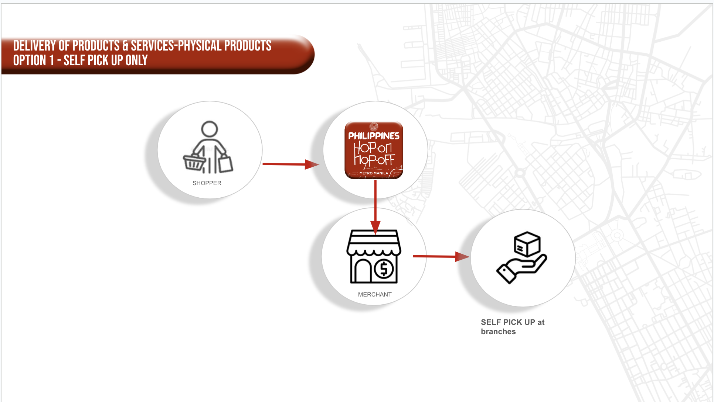

### Option 1: Self-Pickup

* Process:
  + Shopper makes a purchase through the HOHO platform.
  + Merchants receive a notification of the order.
  + The merchant fulfills the order by preparing the product for the shopper to pick up in person.

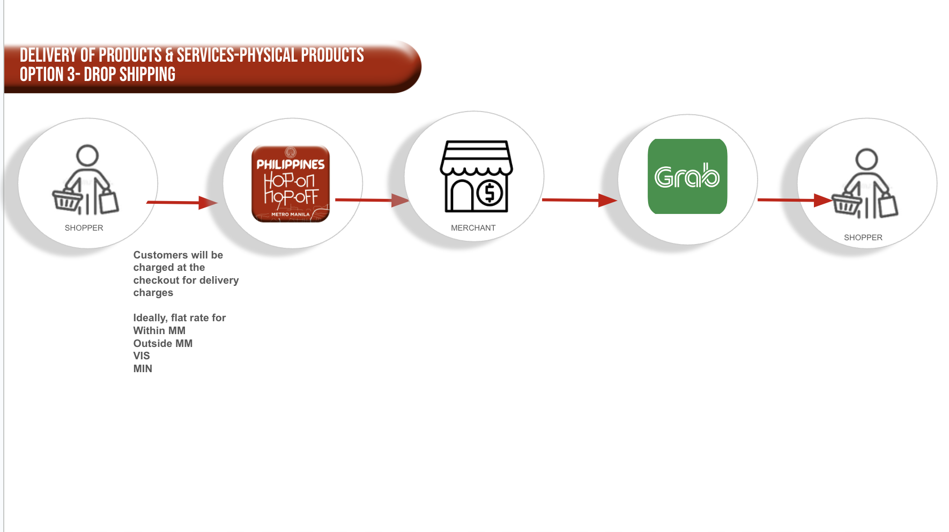

### Option 2: Drop Shipping

* Process:
  + Shopper make a purchase through the HOHO platform.
  + Both the merchant and the courier receive notifications of the order.
  + The merchant prepares the order, and the courier handles the delivery to the shopper’s address.

These options offer flexibility in terms of delivery, where Option 1 focuses on the shopper picking up the product directly from the merchant, while Option 2 relies on the courier to deliver the product.